Patching Process:

* Draft and send the mail with delay delivery on time.

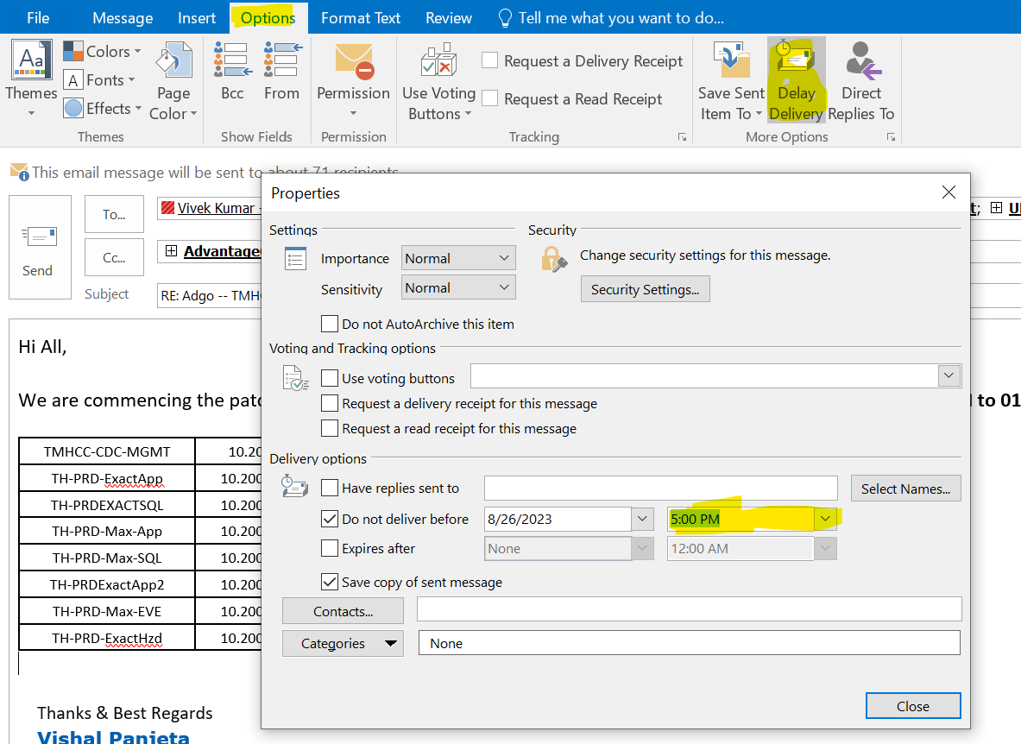

* Filter the servers which are required in patching – can be done by selection by IP address or by selecting only required rgroups- 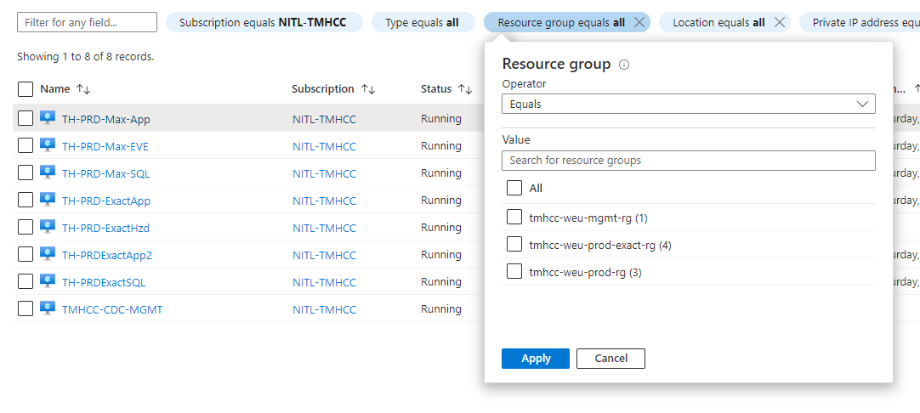
* Now send the Prepatching Snapshot of servers to anyone in chat-
* Now open a script of Snapshot and Edit as per requirement.
* Run the Script over Powershell ISE.
* Now count the snapshots which you taken and match the number with total count of your disks of servers-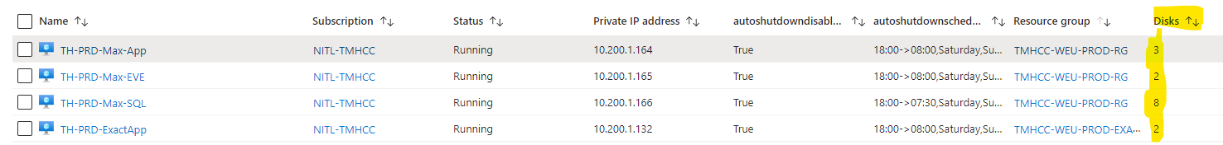
* Now go to WSS server- 10.110.0.37. now select only those patches which are required in that month patching activity also shared by vivek sir over mail .
* Now approve and install the patch from WSS. Now patches has been pushed on servers.
* Now copy the IP with machine name from mail which you sent. Paste into your RDP server.
* For those servers which are required to be run after patching, Write down the sequence to start after their IP address in notepad-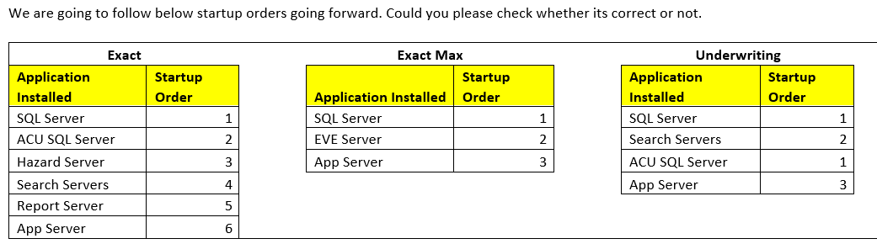
* Now take Remote of each server one by one , Update them and also take their services status before patching. (To open settings , Press – Win +i)
* If Update is not pushed in server by WSS server which we usually observes- You have to turn ON the internet.
* After internet on, click on retry, or you can restart the server which also resolve the issue.

# To On/off the internet-

* Press Windows button, write regedit and enter.
* Now go to RegEdit>HkeyLocalMachine>Software>Policy>Microsoft>Windows>WindowUpdate>AU
* To Switch On the internet- Value should be 0. 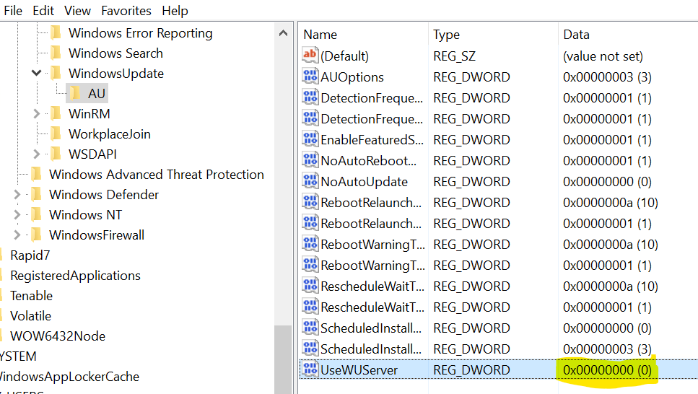
* To Switch OFF the internet, Value should be 1.
* Now after update, stop the servers which required to be stop.
* To create sequence, stop those servers which are after 1 in sequence, and start them one by one and match their services.
* Now after patching is done, send the patching completion mail and update the change also.